APARTADO 1: aplicación Android que muestra 3 opciones en la Action bar. Cada vez que el usuario pulse sobre una de ellas deberá mostrar un texto diferente en pantalla. Personaliza el texto como prefieras.

SOLUCIÓN

LAYOUT MENU

<?xml version="1.0" encoding="utf-8"?>
<menu xmlns:app="http://schemas.android.com/apk/res-auto"
xmlns:android="http://schemas.android.com/apk/res/android">
<item android:id="@+id/item1"
android:title="Leccion de vida"
app:showAsAction="always"/>
<item android:title="Chiste"
android:id="@+id/item2"
app:showAsAction="always"/>
<item android:title="Frase realista"
android:id="@+id/item3"
app:showAsAction="always"/>
</menu>

LAYOUT MAIN

<?xml version="1.0" encoding="utf-8"?>
<androidx.constraintlayout.widget.ConstraintLayout xmlns:android="http://schemas.android.com/apk/res/android"
xmlns:app="http://schemas.android.com/apk/res-auto"
xmlns:tools="http://schemas.android.com/tools"
android:layout_width="match_parent"
android:layout_height="match_parent"
tools:context=".MainActivity">
<TextView
android:id="@+id/textView"
android:layout_width="wrap_content"
android:layout_height="wrap_content"
android:gravity="center"
android:text="Texto de prueba voluuuuuudo"
android:textColor="@color/black"
app:layout_constraintBottom_toBottomOf="parent"
app:layout_constraintEnd_toEndOf="parent"
app:layout_constraintStart_toStartOf="parent"
app:layout_constraintTop_toTopOf="parent" />
</androidx.constraintlayout.widget.ConstraintLayout>

ACTIVITY MAIN

public class MainActivity extends AppCompatActivity {
@Override
protected void onCreate(Bundle savedInstanceState) {
super.onCreate(savedInstanceState);
setContentView(R.layout.activity_main);
}
@Override
public boolean onCreateOptionsMenu(Menu menu) {
MenuInflater inflater = getMenuInflater();
inflater.inflate(R.menu.menu, menu);
return true;
}
@Override
public boolean onOptionsItemSelected(MenuItem item) {
TextView texto = findViewById(R.id.textView);
switch (item.getItemId()) {
case R.id.item1:
texto.setText("No dejes para para mañana lo que puedes hacer hoy");
return true;
case R.id.item2:
texto.setText("¿Cómo se dice no en Sudáfrica? Mopongo");
return true;
case R.id.item3:
texto.setText("Ella no te ama");
return true;
default:
return super.onOptionsItemSelected(item);
}
}
}

SALIDA
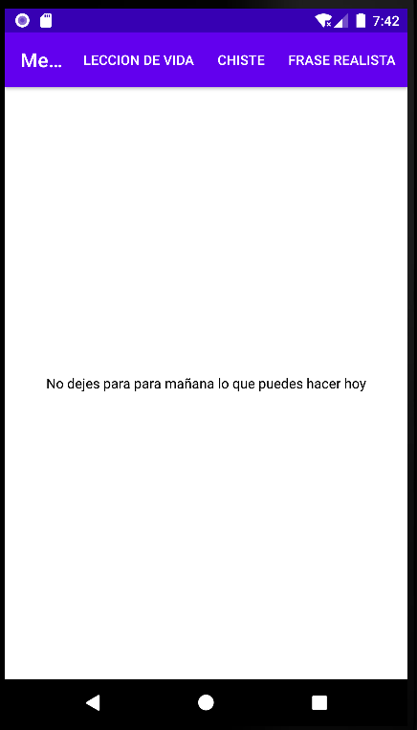

—--------------------------------------------------------------------------------------------—---------------------

APARTADO 2: aplicación Android que permita desplegar el siguiente menú de opciones:
1. Manzanas.
1.1. Golden.
1.2. Verde Doncella.
2. Plátanos.
3. Peras.
3.1. Conferencia.
3.2. Limonera.
Cada vez que el usuario pulse sobre una opción terminal deberá mostrar una imagen de la fruta seleccionada.

SOLUCIÓN
LAYOUT MENU

<?xml version="1.0" encoding="utf-8"?>
<menu xmlns:android="http://schemas.android.com/apk/res/android">
<item android:id="@+id/item1"
android:title="Manzanas">
<menu>
<item android:id="@+id/item11"
android:title="Golden"/>
<item android:id="@+id/item12"
android:title="Verde Doncella"/>
</menu>
</item>
<item android:title="Platanos"
android:id="@+id/item2"/>
<item android:title="Peras"
android:id="@+id/item3">
<menu>
<item android:id="@+id/item31"
android:title="Conferencia"/>
<item android:id="@+id/item32"
android:title="Limonera"/>
</menu>
</item>
</menu>

LAYOUT MAIN
<?xml version="1.0" encoding="utf-8"?>
<androidx.constraintlayout.widget.ConstraintLayout xmlns:android="http://schemas.android.com/apk/res/android"
xmlns:app="http://schemas.android.com/apk/res-auto"
xmlns:tools="http://schemas.android.com/tools"
android:layout_width="match_parent"
android:layout_height="match_parent"
tools:context=".MainActivity">
<ImageView
android:id="@+id/frutas"
android:layout_width="361dp"
android:layout_height="394dp"
app:layout_constraintBottom_toBottomOf="parent"
app:layout_constraintEnd_toEndOf="parent"
app:layout_constraintStart_toStartOf="parent"
app:layout_constraintTop_toTopOf="parent"
app:srcCompat="@mipmap/frutas_foreground" />
</androidx.constraintlayout.widget.ConstraintLayout>
ACTIVITY MAIN
public class MainActivity extends AppCompatActivity {
@Override
protected void onCreate(Bundle savedInstanceState) {
super.onCreate(savedInstanceState);
setContentView(R.layout.activity_main);
}
@Override
public boolean onCreateOptionsMenu(Menu menu) {
MenuInflater inflater = getMenuInflater();
inflater.inflate(R.menu.menu, menu);
return true;
}
@Override
public boolean onOptionsItemSelected(MenuItem item) {
ImageView img = findViewById(R.id.frutas);
switch (item.getItemId()) {
case R.id.item11:
img.setImageResource(R.mipmap.manzana_golden_foreground);
return true;
case R.id.item12:
img.setImageResource(R.mipmap.manzana_verde_doncella_foreground);
return true;
case R.id.item2:
img.setImageResource(R.mipmap.platanos_foreground);
return true;
case R.id.item31:
img.setImageResource(R.mipmap.peras_conferencia_foreground);
return true;
case R.id.item32:
img.setImageResource(R.mipmap.peras_limoneras_foreground);
return true;
default:
return super.onOptionsItemSelected(item);
}
}
}
—--------------------------------------------------------------------------------------------—---------------------
SALIDA

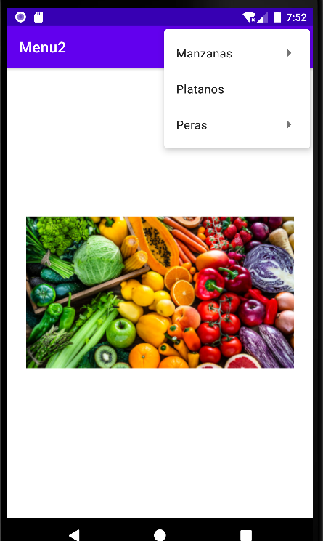

APARTADO 3: Aplicación Android que muestre la siguiente pantalla. Estará compuesta por dos fragments. Cuando el usuario pulse sobre un ítem en el fragment superior deberá mostrarse una imagen de la fruta correspondiente en el fragment inferior.

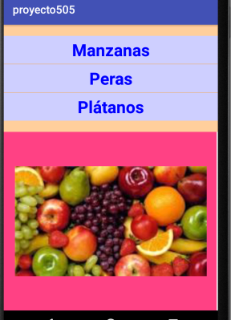
SOLUCIÓN
MAIN LAYOUT
<?xml version="1.0" encoding="utf-8"?>
<androidx.constraintlayout.widget.ConstraintLayout xmlns:android="http://schemas.android.com/apk/res/android"
xmlns:app="http://schemas.android.com/apk/res-auto"
xmlns:tools="http://schemas.android.com/tools"
android:layout_width="match_parent"
android:layout_height="match_parent"
tools:context=".MainActivity">
<fragment
android:id="@+id/fragment1"
android:layout_width="match_parent"
android:layout_height="270dp"
android:text="Hello World!"
app:layout_constraintBottom_toBottomOf="parent"
app:layout_constraintHorizontal_bias="0.0"
app:layout_constraintLeft_toLeftOf="parent"
app:layout_constraintRight_toRightOf="parent"
app:layout_constraintTop_toTopOf="parent"
app:layout_constraintVertical_bias="0.0"
class="com.example.fragments.SuperiorFragment"/>
<fragment
android:id="@+id/fragment2"
android:layout_width="match_parent"
android:layout_height="465dp"
app:layout_constraintBottom_toBottomOf="parent"
app:layout_constraintEnd_toEndOf="parent"
app:layout_constraintStart_toStartOf="parent"
app:layout_constraintTop_toBottomOf="@+id/fragment1"
class="com.example.fragments.InferiorFragment" />
</androidx.constraintlayout.widget.ConstraintLayout>

FRAGMENT INFERIOR LAYOUT
<?xml version="1.0" encoding="utf-8"?>
<androidx.constraintlayout.widget.ConstraintLayout xmlns:android="http://schemas.android.com/apk/res/android"
xmlns:app="http://schemas.android.com/apk/res-auto"
xmlns:tools="http://schemas.android.com/tools"
android:layout_width="match_parent"
android:layout_height="match_parent"
android:background="@color/pink"
tools:context=".InferiorFragment">
<ImageView
android:id="@+id/imageView"
android:layout_width="269dp"
android:layout_height="238dp"
android:src="@mipmap/conjunto_frutas_foreground"
app:layout_constraintBottom_toBottomOf="parent"
app:layout_constraintEnd_toEndOf="parent"
app:layout_constraintStart_toStartOf="parent"
app:layout_constraintTop_toTopOf="parent" />
</androidx.constraintlayout.widget.ConstraintLayout>

FRAGMENT SUPERIOR LAYOUT

<?xml version="1.0" encoding="utf-8"?>
<androidx.constraintlayout.widget.ConstraintLayout xmlns:android="http://schemas.android.com/apk/res/android"
xmlns:app="http://schemas.android.com/apk/res-auto"
xmlns:tools="http://schemas.android.com/tools"
android:layout_width="match_parent"
android:layout_height="match_parent"
android:background="@color/orange"
tools:context=".SuperiorFragment">
<Button
android:id="@+id/manzanas"
android:layout_width="350dp"
android:layout_height="wrap_content"
android:layout_marginTop="32dp"
android:text="Manzanas"
android:textStyle="bold"
android:backgroundTint="@color/lightBlue"
android:textColor="@color/blue"
app:layout_constraintEnd_toEndOf="parent"
app:layout_constraintHorizontal_bias="0.498"
app:layout_constraintStart_toStartOf="parent"
app:layout_constraintTop_toTopOf="parent" />
<Button
android:id="@+id/peras"
android:layout_width="350dp"
android:layout_height="wrap_content"
android:text="Peras"
android:textStyle="bold"
android:backgroundTint="@color/lightBlue"
android:textColor="@color/blue"
app:layout_constraintEnd_toEndOf="parent"
app:layout_constraintHorizontal_bias="0.498"
app:layout_constraintStart_toStartOf="parent"
app:layout_constraintTop_toBottomOf="@+id/manzanas" />
<Button
android:id="@+id/platanos"
android:layout_width="350dp"
android:layout_height="wrap_content"
android:text="Plátanos"
android:backgroundTint="@color/lightBlue"
android:textStyle="bold"
android:textColor="@color/blue"
app:layout_constraintEnd_toEndOf="parent"
app:layout_constraintStart_toStartOf="parent"
app:layout_constraintTop_toBottomOf="@+id/peras" />
</androidx.constraintlayout.widget.ConstraintLayout>

MAIN ACTIVITY

public class MainActivity extends AppCompatActivity {
@Override
protected void onCreate(Bundle savedInstanceState) {
super.onCreate(savedInstanceState);
setContentView(R.layout.activity_main);
Button manzana = findViewById(R.id.manzanas);
Button pera = findViewById(R.id.peras);
Button platano = findViewById(R.id.platanos);
ImageView img = findViewById(R.id.imageView);
manzana.setOnClickListener(new View.OnClickListener() {
@Override
public void onClick(View v) {
img.setImageResource(R.mipmap.manzana_foreground);
}
});
pera.setOnClickListener(new View.OnClickListener() {
@Override
public void onClick(View v) {
img.setImageResource(R.mipmap.peras_foreground);
}
});
platano.setOnClickListener(new View.OnClickListener() {
@Override
public void onClick(View v) {
img.setImageResource(R.mipmap.platano_foreground);
}
});
}
}

FRAGMENT SUPERIOR JAVA
public class SuperiorFragment extends Fragment {
// TODO: Rename parameter arguments, choose names that match
// the fragment initialization parameters, e.g. ARG_ITEM_NUMBER
private static final String ARG_PARAM1 = "param1";
private static final String ARG_PARAM2 = "param2";
// TODO: Rename and change types of parameters
private String mParam1;
private String mParam2;
public SuperiorFragment() {
// Required empty public constructor
}
/**
* Use this factory method to create a new instance of
* this fragment using the provided parameters.
*
* @param param1 Parameter 1.
* @param param2 Parameter 2.
* @return A new instance of fragment SuperiorFragment.
*/
// TODO: Rename and change types and number of parameters
public static SuperiorFragment newInstance(String param1, String param2) {
SuperiorFragment fragment = new SuperiorFragment();
Bundle args = new Bundle();
args.putString(ARG_PARAM1, param1);
args.putString(ARG_PARAM2, param2);
fragment.setArguments(args);
return fragment;
}
@Override
public void onCreate(Bundle savedInstanceState) {
super.onCreate(savedInstanceState);
if (getArguments() != null) {
mParam1 = getArguments().getString(ARG_PARAM1);
mParam2 = getArguments().getString(ARG_PARAM2);
}
}
@Override
public View onCreateView(LayoutInflater inflater, ViewGroup container,
Bundle savedInstanceState) {
// Inflate the layout for this fragment
return inflater.inflate(R.layout.fragment_superior, container, false);
}
}

FRAGMENT INFERIOR JAVA

public class InferiorFragment extends Fragment {
// TODO: Rename parameter arguments, choose names that match
// the fragment initialization parameters, e.g. ARG_ITEM_NUMBER
private static final String ARG_PARAM1 = "param1";
private static final String ARG_PARAM2 = "param2";
// TODO: Rename and change types of parameters
private String mParam1;
private String mParam2;
public InferiorFragment() {
// Required empty public constructor
}
/**
* Use this factory method to create a new instance of
* this fragment using the provided parameters.
*
* @param param1 Parameter 1.
* @param param2 Parameter 2.
* @return A new instance of fragment InferiorFragment.
*/
// TODO: Rename and change types and number of parameters
public static InferiorFragment newInstance(String param1, String param2) {
InferiorFragment fragment = new InferiorFragment();
Bundle args = new Bundle();
args.putString(ARG_PARAM1, param1);
args.putString(ARG_PARAM2, param2);
fragment.setArguments(args);
return fragment;
}
@Override
public void onCreate(Bundle savedInstanceState) {
super.onCreate(savedInstanceState);
if (getArguments() != null) {
mParam1 = getArguments().getString(ARG_PARAM1);
mParam2 = getArguments().getString(ARG_PARAM2);
}
}
@Override
public View onCreateView(LayoutInflater inflater, ViewGroup container,
Bundle savedInstanceState) {
// Inflate the layout for this fragment
return inflater.inflate(R.layout.fragment_inferior, container, false);
}
}

SALIDA

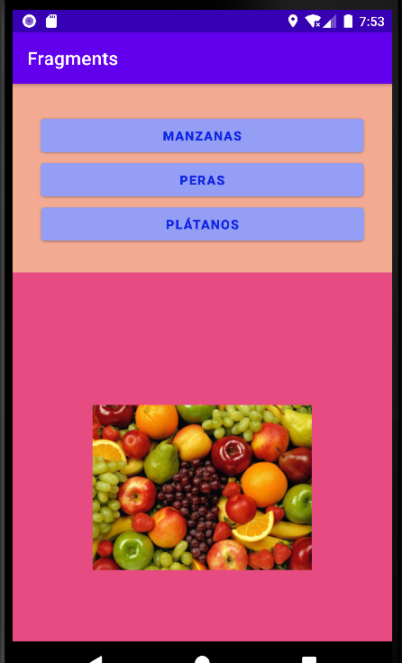
—--------------------------------------------------------------------------------------------—---------------------

APARTADO 4: similar al proyecto anterior pero con el aspecto de la siguiente imagen.

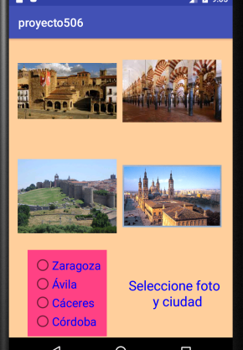

SOLUCIÓN
MAIN LAYOUT
<?xml version="1.0" encoding="utf-8"?>
<androidx.constraintlayout.widget.ConstraintLayout xmlns:android="http://schemas.android.com/apk/res/android"
xmlns:app="http://schemas.android.com/apk/res-auto"
xmlns:tools="http://schemas.android.com/tools"
android:layout_width="match_parent"
android:layout_height="match_parent"
android:background="@color/teal_200"
tools:context=".MainActivity">
<ImageView
android:id="@+id/ivAvila"
android:layout_width="wrap_content"
android:layout_height="wrap_content"
android:layout_marginTop="32dp"
android:clickable="true"
android:focusable="true"
app:layout_constraintEnd_toEndOf="parent"
app:layout_constraintHorizontal_bias="0.217"
app:layout_constraintStart_toStartOf="parent"
app:layout_constraintTop_toTopOf="parent"
app:srcCompat="@mipmap/avila_foreground" />
<ImageView
android:id="@+id/ivCaceres"
android:layout_width="wrap_content"
android:layout_height="wrap_content"
android:layout_marginTop="32dp"
app:layout_constraintEnd_toEndOf="parent"
app:layout_constraintHorizontal_bias="0.217"
app:layout_constraintStart_toStartOf="parent"
app:layout_constraintTop_toBottomOf="@+id/ivAvila"
app:srcCompat="@mipmap/caceres_foreground" />
<ImageView
android:id="@+id/ivCordoba"
android:layout_width="wrap_content"
android:layout_height="wrap_content"
android:layout_marginTop="32dp"
app:layout_constraintEnd_toEndOf="parent"
app:layout_constraintHorizontal_bias="0.745"
app:layout_constraintStart_toStartOf="parent"
app:layout_constraintTop_toTopOf="parent"
app:srcCompat="@mipmap/cordoba_foreground" />
<ImageView
android:id="@+id/ivZaragoza"
android:layout_width="wrap_content"
android:layout_height="wrap_content"
android:layout_marginTop="32dp"
app:layout_constraintEnd_toEndOf="parent"
app:layout_constraintHorizontal_bias="0.745"
app:layout_constraintStart_toStartOf="parent"
app:layout_constraintTop_toBottomOf="@+id/ivCordoba"
app:srcCompat="@mipmap/zaragoza_foreground" />
<fragment
android:id="@+id/fragment_container"
android:name="com.example.fragments2.FragmentGroup"
android:layout_width="wrap_content"
android:layout_height="wrap_content"
android:layout_marginTop="316dp"
app:layout_constraintEnd_toEndOf="parent"
app:layout_constraintHorizontal_bias="0.206"
app:layout_constraintStart_toStartOf="parent"
app:layout_constraintTop_toTopOf="parent"
tools:layout="@layout/fragment_group" />
<TextView
android:id="@+id/textView"
android:layout_width="96dp"
android:layout_height="60dp"
android:layout_marginTop="364dp"
android:text="Seleccione foto y ciudad"
android:textColor="@color/blue"
app:layout_constraintEnd_toEndOf="parent"
app:layout_constraintHorizontal_bias="0.717"
app:layout_constraintStart_toStartOf="parent"
app:layout_constraintTop_toTopOf="parent" />
</androidx.constraintlayout.widget.ConstraintLayout>
FRAGMENT LAYOUT
<?xml version="1.0" encoding="utf-8"?>
<androidx.constraintlayout.widget.ConstraintLayout xmlns:android="http://schemas.android.com/apk/res/android"
xmlns:tools="http://schemas.android.com/tools"
xmlns:app="http://schemas.android.com/apk/res-auto"
android:layout_width="match_parent"
android:layout_height="match_parent"
tools:context=".FragmentGroup">
<RadioGroup
android:layout_width="120dp"
android:layout_height="wrap_content"
android:background="#CA3754"
app:layout_constraintEnd_toEndOf="parent"
app:layout_constraintHorizontal_bias="0.451"
app:layout_constraintStart_toStartOf="parent"
app:layout_constraintTop_toTopOf="parent">
<RadioButton
android:id="@+id/zaragoza"
android:layout_width="match_parent"
android:layout_height="wrap_content"
android:text="Zaragoza"
android:textColor="@color/blue"
android:textStyle="bold" />
<RadioButton
android:id="@+id/avila"
android:layout_width="match_parent"
android:layout_height="wrap_content"
android:text="Ávila"
android:textColor="@color/blue"
android:textStyle="bold" />
<RadioButton
android:id="@+id/caceres"
android:layout_width="match_parent"
android:layout_height="wrap_content"
android:text="Cáceres"
android:textColor="@color/blue"
android:textStyle="bold" />
<RadioButton
android:id="@+id/cordoba"
android:layout_width="match_parent"
android:layout_height="wrap_content"
android:text="Córdoba"
android:textColor="@color/blue"
android:textStyle="bold" />
</RadioGroup>
</androidx.constraintlayout.widget.ConstraintLayout>
MAIN ACTIVITY
public class MainActivity extends AppCompatActivity {
RadioButton rbCordoba;
RadioButton rbZaragoza;
RadioButton rbCaceres;
RadioButton rbAvila;
@Override
protected void onCreate(Bundle savedInstanceState) {
super.onCreate(savedInstanceState);
setContentView(R.layout.activity_main);
TextView tv = findViewById(R.id.textView);
rbCordoba = findViewById(R.id.cordoba);
rbZaragoza = findViewById(R.id.zaragoza);
rbCaceres = findViewById(R.id.caceres);
rbAvila = findViewById(R.id.avila);
ImageView ivCordoba = findViewById(R.id.ivCordoba);
ImageView ivAvila = findViewById(R.id.ivAvila);
ImageView ivCaceres = findViewById(R.id.ivCaceres);
ImageView ivZaragoza = findViewById(R.id.ivZaragoza);
ivCordoba.setOnClickListener(new View.OnClickListener() {
@Override
public void onClick(View v) {
if (comprobacion() == true) {
if (rbCordoba.isChecked()) {
tv.setText("Correcto");
} else {
tv.setText("Incorrecto");
}
} else{
tv.setText("Primero marca una opcion");
}
}
});
ivAvila.setOnClickListener(new View.OnClickListener() {
@Override
public void onClick(View v) {
if (comprobacion() == true) {
if (rbAvila.isChecked()){
tv.setText("Correcto");
} else {
tv.setText("Incorrecto");
}
} else{
tv.setText("Primero marca una opcion");
}
}
});
ivCaceres.setOnClickListener(new View.OnClickListener() {
@Override
public void onClick(View v) {
if (comprobacion() == true) {
if (rbCaceres.isChecked()){
tv.setText("Correcto");
} else {
tv.setText("Incorrecto");
}
} else{
tv.setText("Primero marca una opcion");
}
}
});
ivZaragoza.setOnClickListener(new View.OnClickListener() {
@Override
public void onClick(View v) {
if (comprobacion() == true) {
if (rbZaragoza.isChecked()){
tv.setText("Correcto");
} else {
tv.setText("Incorrecto");
}
} else{
tv.setText("Primero marca una opcion");
}
}
}
);
}
private boolean comprobacion(){
boolean comprobar = false;
if (rbAvila.isChecked() || rbCordoba.isChecked() || rbCaceres.isChecked() || rbZaragoza.isChecked()) {
comprobar = true;
}
return comprobar;
}
}
FRAGMENT ACTIVITY
public class FragmentGroup extends Fragment {
@Override
public View onCreateView(LayoutInflater inflater, ViewGroup container,
Bundle savedInstanceState) {
// Inflate the layout for this fragment
return inflater.inflate(R.layout.fragment_group, container, false);
}
}
SALIDA



